PROJECT DOCUMENTATION

**HIGHLIGHT REPORT**

|  |  |
| --- | --- |
| **Project:** | **E-Commerce Website for SKANDA**  **by Sarasi Samarasinghe** |
| Release: | April 2022 |
| Date: | 24th March 2022 |
| Period Covered: | 07/02/2022 – 24/03/2022 |
|  |  |
| **PRINCE2** |  |
|  |  |
| Author: | S. K. Helani Sihara Jayawardena, M.Sonali Silva |
| Owner: | Dr. Yasas Jayaweera (Project Executive) |
| Client: | Mrs Sarasi Samarasundara. |
| Document Ref: | ProjectHighlightReport_SKANDA |
| Version No: | 1.1 |

# 1 Highlight Report History

## 1.1 Document Location

This document is only valid on the day it was printed.

The source of the document will be found on the project's PC in location

## 1.2 Revision History

**Date of this revision:** 24/03/2022

**Date of Next revision:**

|  |  |  |  |
| --- | --- | --- | --- |
| **Revision date** | **Previous revision date** | **Summary of Changes** | **Changes marked** |
| 24/03/2022 | 08/03/2022 | Budget calculation for week 6 and 7 |  |

## 1.3 Approvals

This document requires the following approvals.

Signed approval forms are filed in the Management section of the project files.

|  |  |  |  |  |
| --- | --- | --- | --- | --- |
| **Name** | **Signature** | **Title** | **Date of Issue** | **Version** |
| Dr Yasas Jayaweera |  | Project Board | 24/03/2022 | 1.1 |
| Adithya Narasinghe |  | Project Manager | 24/03/2022 | 1.1 |
| Mrs. Sarasi Samarasundara |  | Client | 24/03/2022 | 1.1 |

## 1.4 Distribution

This document has been distributed to:

|  |  |  |  |
| --- | --- | --- | --- |
| **Name** | **Title** | **Date of Issue** | **Version** |
| Adithya Narasinghe | Project Manager | 24/03/2022 | 1.1 |
| M. Sonali Silva | Start-up Manager | 24/03/2022 | 1.1 |
| J. M. Pasindu Lawantha Bandara | Quality Manager | 24/03/2022 | 1.1 |
| Madapathage Don Kanishka Gimhan | Risk Manager | 24/03/2022 | 1.1 |
| S. K. Helani Sihara Jayawardena | Scheduling Manager | 24/03/2022 | 1.1 |

# 2 Table of Contents

1 Highlight Report History **2**

1.1 Document Location 2

1.2 Revision History 2

1.3 Approvals 2

1.4 Distribution 2

2 Table of Contents **1**

3 List of Tables **2**

Highlight Report **2**

4 Purpose 3

5 Budget Status 3

6 Schedule Status 15

7 Products-Completed 17

8 Problems and Risk Update 18

9 Products to be Completed 18

10 Project Issue Status 18

11 Budget/Schedule Impact 19

# 3 List of Tables

Table 1:Planned budget Vs actual cost 1

Table 2:Week 1 Budget vs Cost 2

Table 3:Week 2 Budget vs Cost 3

Table 4: Week 3 Budget vs Cost 4

Table 5:Week 4 Budget vs Cost 5

Table 6:Week 5 Budget vs Cost 7

Table 7:Week 6 Budget vs Cost 9

Table 8:Week 7 Budget vs Cost 11

# 

4 Table of Figures

# 

Figure 1:Scheduled Tasks Vs Completed tasks in week 1 13

Figure 2:Scheduled Tasks Vs Completed tasks in week 2 13

Figure 3: 13

Figure 4:Scheduled Tasks Vs Completed tasks in week 3 14

Figure 5:Scheduled Tasks Vs Completed tasks in week 5 14

Figure 6:Scheduled Tasks Vs Completed tasks in week 6 14

Figure 7:Scheduled Tasks Vs Completed tasks in week 6 15

Figure 8:Scheduled Tasks Vs Completed tasks in week 7 15

# Highlight Report

## 4 Purpose

This highlight report's purpose is to update the SKANDA E-commerce website's development. The development team had finished and submitted all the required documentation by the date specified in this document. Tasks were completed under the supervision of project board member Dr. Yasas Jayaweera. In addition, the development team has begun the basic creation of SKANDA's E-Commerce website.

## 5 Budget Status

The following tables illustrate the current budget status of the SKANDA E-commerce website. As of March 24th, 2022, the team spent around 74% of the initial budget. Set fee of payment gateway is completed, and the website will deploy using namecheap shared hosting. All expenditures are recorded accordingly. During each group meeting, the team members, including the project manager, discuss the current budget status.

Table :Planned budget Vs actual cost

|  |  |  |
| --- | --- | --- |
| **Week** | **Planned Budget** | **Actual Cost** |
| Week 01 | 1,500 | 1,500 |
| Week 02 | 1,500 | 1,500 |
| Week 03 | 6,500 | 6,500 |
| Week 04 | 17,500 | 15,080 |
| Week 05 | 17,000 | 16,000 |
| Week 06 | 20,500 | 19,375 |
| Week 07 | 57,380 | 55,255 |

Table :Week 1 Budget vs Cost

|  |  |  |  |  |  |  |  |  |
| --- | --- | --- | --- | --- | --- | --- | --- | --- |
| **Estimated Budget** | | | | | | **Week 01 Status** | | |
| **Expense** | **Description** | **Basis** | **Unit** | **Rate** | **Amount** | **Unit** | **Rate** | **Spent** |
| **Charges for the setup** | | | | | | | | |
| Domain Purchasing | Registration of Domain (Skandabysarasi.com) | Per domain | 1 | 5,000 | 5,000 | - | - | - |
| Purchasing a hosting service | Purchase of space for Hosting | Per year | 1 | 8,000 | 8,000 | - | - | - |
| Purchasing a WordPress template | Purchasing a WordPress template. | One time purchase | 1 | 12,000 | 12,000 | - | - | - |
| Set Fee of Payment Gateway | To accept online Payments | Per year | 1 | 35,880 | 35,880 | - | - | - |
| **Planning** | | | | | | | | |
| Client Requirement | Consultation | Per Hour | 4 | 1,500 | 6,000 | 1 | 1,500 | 1,500 |
| Other Expenses | Printouts & Photocopy | Per Copy | 100 | 10 | 1000 | - | - | - |
| **Design and Development** | | | | | | | | |
| Content Writing | Documents and the Website Contents | Per Hour | 20 | 500 | 10,000 | - | - | - |
| Web Designing and Development | According to the approved designs development parts | Per Hour | 40 | 1,000 | 40,000 | - | - | - |
| Graphic Designs | According to the approved design | Per Artwork | 15 | 1,000 | 15,000 | - | - | - |
| **Implementation** | | | | | | | | |
| Final Review of the Project | Final Testing and implementation | Per Hour | 15 | 1,000 | 15,000 | - | - | - |
| **Weekly Budget Status** | | | | | | | | |
| Week 01 expenses | | | | | | | | 1,500 |
| **Total Budget Status** | | | | | | | | |
|  | | | | | | Total Spent | | 1,500 |
| **Total Estimated Cost** | | | | | 147,880 | Budget Left | | 146,380 |

Table :Week 2 Budget vs Cost

|  |  |  |  |  |  |  |  |  |
| --- | --- | --- | --- | --- | --- | --- | --- | --- |
| **Estimated Budget** | | | | | | **Week 02 Status** | | |
| **Expense** | **Description** | **Basis** | **Unit** | **Rate** | **Amount** | **Unit** | **Rate** | **Spent** |
| **Charges for the setup** | | | | | | | | |
| Domain Purchasing | Registration of Domain (Skandabysarasi.com) | Per domain | 1 | 5,000 | 5,000 | - | - | - |
| Purchasing a hosting service | Purchase of space for Hosting | Per year | 1 | 8,000 | 8,000 | - | - | - |
| Purchasing a WordPress template | Purchasing a WordPress template. | One time purchase | 1 | 12,000 | 12,000 | - | - | - |
| Set Fee of Payment Gateway | To accept online Payments | Per year | 1 | 35,880 | 35,880 | - | - | - |
| **Planning** | | | | | | | | |
| Client Requirement | Consultation | Per Hour | 4 | 1,500 | 6,000 | 1 | 1,500 | 1,500 |
| Other Expenses | Printouts & Photocopy | Per Copy | 100 | 10 | 1000 | - | - | - |
| **Design and Development** | | | | | | | | |
| Content Writing | Documents and the Website Contents | Per Hour | 20 | 500 | 10,000 | - | - | - |
| Web Designing and Development | According to the approved designs development parts | Per Hour | 40 | 1,000 | 40,000 | - | - | - |
| Graphic Designs | According to the approved design | Per Artwork | 15 | 1,000 | 15,000 | - | - | - |
| **Implementation** | | | | | | | | |
| Final Review of the Project | Final Testing and implementation | Per Hour | 15 | 1,000 | 15,000 | - | - | - |
| **Weekly Budget Status** | | | | | | | | |
| Week 02 expenses | | | | | | | | 1,500 |
| Week 01 expenses | | | | | | | | 1,500 |
| **Total Budget Status** | | | | | | | | |
|  | | | | | | Total Spent | | 3,000 |
| **Total Estimated Cost** | | | | | 147,880 | Budget Left | | 144,880 |

Table : Week 3 Budget vs Cost

|  |  |  |  |  |  |  |  |  |
| --- | --- | --- | --- | --- | --- | --- | --- | --- |
| **Estimated Budget** | | | | | | **Week 03 Status** | | |
| **Expense** | **Description** | **Basis** | **Unit** | **Rate** | **Amount** | **Unit** | **Rate** | **Spent** |
| **Charges for the setup** | | | | | | | | |
| Domain Purchasing | Registration of  (Skandabysarasi.com) | Per domain | 1 | 5,000 | 5,000 | - | - | - |
| Purchasing a hosting service | Purchase of space for Hosting | Per year | 1 | 8,000 | 8,000 | - | - | - |
| Purchasing a WordPress template | Purchasing a WordPress template. | One time purchase | 1 | 12,000 | 12,000 | - | - | - |
| Set Fee of Payment Gateway | To accept online Payments | Per year | 1 | 35,880 | 35,880 | - | - | - |
| **Planning** | | | | | | | | |
| Client Requirement | Consultation | Per Hour | 4 | 1,500 | 6,000 | 1 | 1,500 | 1,500 |
| Other Expenses | Printouts & Photocopy | Per Copy | 100 | 10 | 1000 | - | - | - |
| **Design and Development** | | | | | | | | |
| Content Writing | Documents and the Website Contents | Per Hour | 20 | 500 | 10,000 | 6 | 500 | 3000 |
| Web Designing and Development | According to the approved designs development parts | Per Hour | 40 | 1,000 | 40,000 | - | - | - |
| Graphic Designs | According to the approved design | Per Artwork | 15 | 1,000 | 15,000 | 2 | 1,000 | 2,000 |
| **Implementation** | | | | | | | | |
| Final Review of the Project | Final Testing and implementation | Per Hour | 15 | 1,000 | 15,000 | - | - | - |
| **Weekly Budget Status** | | | | | | | | |
| Week 03 expenses | | | | | | | | 6,500 |
| Week 02 expenses | | | | | | | | 1,500 |
| Week 01 expenses | | | | | | | | 1,500 |
| **Total Budget Status** | | | | | | | | |
|  | | | | | | Total Spent | | 9,500 |
| **Total Estimated Cost** | | | | | 147,880 | Budget Left | | 138,380 |

Table :Week 4 Budget vs Cost

|  |  |  |  |  |  |  |  |  |
| --- | --- | --- | --- | --- | --- | --- | --- | --- |
| **Estimated Budget** | | | | | | **Week 04 Status** | | |
| **Expense** | **Description** | **Basis** | **Unit** | **Rate** | **Amount** | **Unit** | **Rate** | **Spent** |
| **Charges for the setup** | | | | | | | | |
| Domain Purchasing | Registration of Domain (Skandabysarasi.com) | Per domain | 1 | 5,000 | 5,000 | 1 | 3,450 | 3,450 |
| Purchasing a hosting service | Purchase of space for Hosting | Per year | 1 | 8,000 | 8,000 | 1 | 7,880 | 7,880 |
| Purchasing a WordPress template | Purchasing a WordPress template. | One time purchase | 1 | 12,000 | 12,000 | - | - | - |
| Set Fee of Payment Gateway | To accept online Payments | Per year | 1 | 35,880 | 35,880 | - | - | - |
| **Planning** | | | | | | | | |
| Client Requirement | Consultation | Per Hour | 4 | 1,500 | 6,000 | 0.5 | 750 | 750 |
| Other Expenses | Printouts & Photocopy | Per Copy | 100 | 10 | 1000 | - | - | - |
| **Design and Development** | | | | | | | | |
| Content Writing | Documents and the Website Contents | Per Hour | 20 | 500 | 10,000 | - | - | - |
| Web Designing and Development | According to the approved designs development parts | Per Hour | 40 | 1,000 | 40,000 | 3 | 1,000 | 3,000 |
| Graphic Designs | According to the approved design | Per Artwork | 15 | 1,000 | 15,000 | - | - | - |
| **Implementation** | | | | | | | | |
| Final Review of the Project | Final Testing and implementation | Per Hour | 15 | 1,000 | 15,000 | - | - | - |
| **Weekly Budget Status** | | | | | | | | |
| Week 04 expenses | | | | | | | | 15,080 |
| Week 03 expenses | | | | | | | | 6,500 |
| Week 02 expenses | | | | | | | | 1,500 |
| Week 01 expenses | | | | | | | | 1,500 |
| **Total Budget Status** | | | | | | | | |
|  | | | | | | Total Spent | | 24,580 |
| **Total Estimated Cost** | | | | | 147,880 | Budget Left | | 123,300 |

Table :Week 5 Budget vs Cost

|  |  |  |  |  |  |  |  |  |
| --- | --- | --- | --- | --- | --- | --- | --- | --- |
| **Estimated Budget** | | | | | | **Week 05 Status** | | |
| **Expense** | **Description** | **Basis** | **Unit** | **Rate** | **Amount** | **Unit** | **Rate** | **Spent** |
| **Charges for the setup** | | | | | | | | |
| Domain Purchasing | Registration of Domain (Skandabysarasi.com) | Per domain | 1 | 5,000 | 5,000 | - | - | - |
| Purchasing a hosting service | Purchase of space for Hosting | Per year | 1 | 8,000 | 8,000 | - | - | - |
| Purchasing a WordPress template | Purchasing a WordPress template. | One time purchase | 1 | 12,000 | 12,000 | 1 | 11,000 | 11,000 |
| Set Fee of Payment Gateway | To accept online Payments | Per year | 1 | 35,880 | 35,880 | - | - | - |
| **Planning** | | | | | | | | |
| Client Requirement | Consultation | Per Hour | 4 | 1,500 | 6,000 | - | - | - |
| Other Expenses | Printouts & Photocopy | Per Copy | 100 | 10 | 1000 | - | - | - |
| **Design and Development** | | | | | | | | |
| Content Writing | Documents and the Website Contents | Per Hour | 20 | 500 | 10,000 | - | - | - |
| Web Designing and Development | According to the approved designs development parts | Per Hour | 40 | 1,000 | 40,000 | 5 | 1,000 | 5,000 |
| Graphic Designs | According to the approved design | Per Artwork | 15 | 1,000 | 15,000 | - | - | - |
| **Implementation** | | | | | | | | |
| Final Review of the Project | Final Testing and implementation | Per Hour | 15 | 1,000 | 15,000 | - | - | - |
| **Weekly Budget Status** | | | | | | | | |
| Week 05 expenses | | | | | | | | 16,000 |
| Week 04 expenses | | | | | | | | 15,080 |
| Week 03 expenses | | | | | | | | 6,500 |
| Week 02 expenses | | | | | | | | 1,500 |
| Week 01 expenses | | | | | | | | 1,500 |
| **Total Budget Status** | | | | | | | | |
|  | | | | | | Total Spent | | 40,580 |
| **Total Estimated Cost** | | | | | 147,880 | Budget Left | | 107,300 |

Table :Week 6 Budget vs Cost

|  |  |  |  |  |  |  |  |  |
| --- | --- | --- | --- | --- | --- | --- | --- | --- |
| **Estimated Budget** | | | | | | **Week 06 Status** | | |
| **Expense** | **Description** | **Basis** | **Unit** | **Rate** | **Amount** | **Unit** | **Rate** | **Spent** |
| **Charges for the setup** | | | | | | | | |
| Domain Purchasing | Registration of Domain (Skandabysarasi.com) | Per domain | 1 | 5,000 | 5,000 | - | - | - |
| Purchasing a hosting service | Purchase of space for Hosting | Per year | 1 | 8,000 | 8,000 | - | - | - |
| Purchasing a WordPress template | Purchasing a WordPress template. | One time purchase | 1 | 12,000 | 12,000 | - | - | - |
| Set Fee of Payment Gateway | To accept online Payments | Per year | 1 | 35,880 | 35,880 | - | - | - |
| **Planning** | | | | | | | | |
| Client Requirement | Consultation | Per Hour | 4 | 1,500 | 6,000 | 0.25 | 375 | 375 |
| Other Expenses | Printouts & Photocopy | Per Copy | 100 | 10 | 1000 | - | - | - |
| **Design and Development** | | | | | | | | |
| Content Writing | Documents and the Website Contents | Per Hour | 20 | 500 | 10,000 | 6 | 500 | 3000 |
| Web Designing and Development | According to the approved designs development parts | Per Hour | 40 | 1,000 | 40,000 | 10 | 1,000 | 10,000 |
| Graphic Designs | According to the approved design | Per Artwork | 15 | 1,000 | 15,000 | 6 | 1000 | 6000 |
| **Implementation** | | | | | | | | |
| Final Review of the Project | Final Testing and implementation | Per Hour | 15 | 1,000 | 15,000 | - | - | - |
| **Weekly Budget Status** | | | | | | | | |
| Week 06 expenses | | | | | | | | 19,375 |
| Week 05 expenses | | | | | | | | 16,000 |
| Week 04 expenses | | | | | | | | 15,080 |
| Week 03 expenses | | | | | | | | 6,500 |
| Week 02 expenses | | | | | | | | 1,500 |
| Week 01 expenses | | | | | | | | 1,500 |
| **Total Budget Status** | | | | | | | | |
|  | | | | | | Total Spent | | 59,955 |
| **Total Estimated Cost** | | | | | 147,880 | Budget Left | | 87,925 |

Table :Week 7 Budget vs Cost

|  |  |  |  |  |  |  |  |  |
| --- | --- | --- | --- | --- | --- | --- | --- | --- |
| **Estimated Budget** | | | | | | **Week 07 Status** | | |
| **Expense** | **Description** | **Basis** | **Unit** | **Rate** | **Amount** | **Unit** | **Rate** | **Spent** |
| **Charges for the setup** | | | | | | | | |
| Domain Purchasing | Registration of Domain (Skandabysarasi.com) | Per domain | 1 | 5,000 | 5,000 | - | - | - |
| Purchasing a hosting service | Purchase of space for Hosting | Per year | 1 | 8,000 | 8,000 | - | - | - |
| Purchasing a WordPress template | Purchasing a WordPress template. | One time purchase | 1 | 12,000 | 12,000 | - | - | - |
| Set Fee of Payment Gateway | To accept online Payments | Per year | 1 | 35,880 | 35,880 | 1 | 35,880 | 35,880 |
| **Planning** | | | | | | | | |
| Client Requirement | Consultation | Per Hour | 4 | 1,500 | 6,000 | 025 | 375 | 375 |
| Other Expenses | Printouts & Photocopy | Per Copy | 100 | 10 | 1000 | - | - | - |
| **Design and Development** | | | | | | | | |
| Content Writing | Documents and the Website Contents | Per Hour | 20 | 500 | 10,000 | 6 | 500 | 3,000 |
| Web Designing and Development | According to the approved designs development parts | Per Hour | 40 | 1,000 | 40,000 | 10 | 1,000 | 10,000 |
| Graphic Designs | According to the approved design | Per Artwork | 15 | 1,000 | 15,000 | 6 | 1,000 | 6,000 |
| **Implementation** | | | | | | | | |
| Final Review of the Project | Final Testing and implementation | Per Hour | 15 | 1,000 | 15,000 | - | - | - |
| **Weekly Budget Status** | | | | | | | | |
| Week 07 expenses | | | | | | | | 55,255 |
| Week 06 expenses | | | | | | | | 19,375 |
| Week 05 expenses | | | | | | | | 16,000 |
| Week 04 expenses | | | | | | | | 15,080 |
| Week 03 expenses | | | | | | | | 6,500 |
| Week 02 expenses | | | | | | | | 1,500 |
| Week 01 expenses | | | | | | | | 1,500 |
| **Total Budget Status** | | | | | | | | |
|  | | | | | | Total Spent | | 115,210 |
| **Total Estimated Cost** | | | | | 147,880 | Budget Left | | 32,670 |

## 6 Schedule Status

The team completed all tasks scheduled up to March 10th, 2022. The phases of system planning, requirement gathering, and proposed project design have all commenced successfully. The developers are actively participating in the development to complete the project.

1. Week 01- Requirement Gathering
2. Week 02- Time and cost planning
3. Week 03- Documentation
4. Week 04- Sprint 01
5. Week 05- Sprint 01
6. Week 06- Sprint 02
7. Week 07- Sprint 02
8. Week 07- Sprint 03

Following figures shows completed tasks in each week.



Figure :Scheduled Tasks Vs Completed tasks in week 1

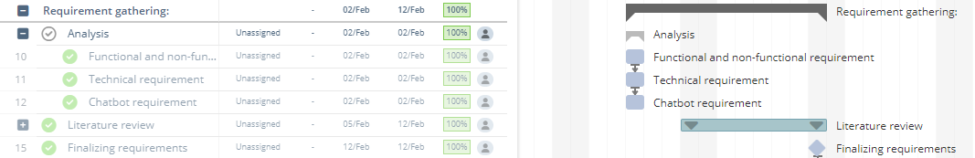



Figure :Scheduled Tasks Vs Completed tasks in week 2

Figure :





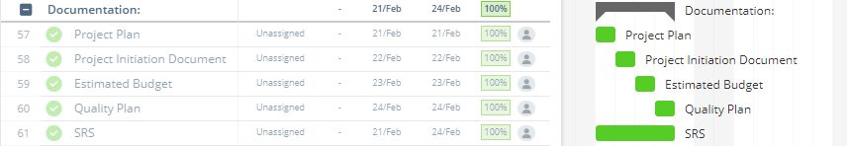

Figure :Scheduled Tasks Vs Completed tasks in week 3



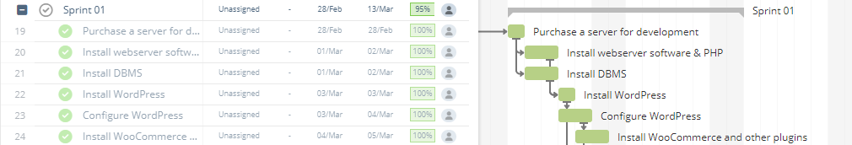

Figure :Scheduled Tasks Vs Completed tasks in week 5

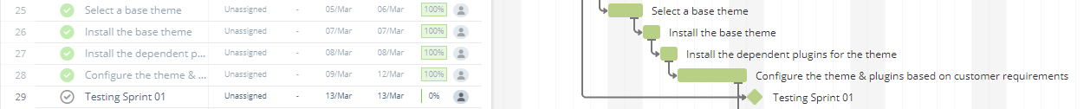

Figure :Scheduled Tasks Vs Completed tasks in week 6

## 

Figure :Scheduled Tasks Vs Completed tasks in week 6

## 

## week 6

## 

Figure :Scheduled Tasks Vs Completed tasks in week 7

## 

## week 7

## 

## 7 Products-Completed

According to the SKANDA E-Commerce Website's product breakdown structure, the following products have been completed. The essential plugins have been installed, GUI work and implementation started on March 14th, 2022, and training of the AI chatbot will commence on week 8 onwards according to Gantt.

**SKANDA’s Website**

* Purchased a server for the project.
* Installed the web server software and PHP.
* Installed the DBMS.
* Installed and configured WordPress.
* Installed woo commerce and other plugins.
* Install and configure the chosen base theme.
* Create and implement GUI designs.
* Add products to the website.
* Install and configure spinning wheel.
* Integrated the payment gateway.
* Sprint 02 testing.
* Set up the AI-chatbot.

**SKANDA’s Project Documents**

* Meeting minutes
* PFD
* PBS
* WBS
* Use Case Diagram
* Class Diagram
* Activity Diagrams
* ER Diagram
* SKANDA’s Software Requirement Specification Document
* Project Brief
* Stage plan
* Project Business Case
* Project plan
* Product description
* Project Initiation Document
* Communication Plan
* Configuration Management Plan
* Project Quality Plan
* Quality checklist
* Quality log
* Risk log
* Risk plan
* Gantt Chart
* Work package
* Lessons learned log
* Risk register
* probability impact grid

## 8 Problems and Risk Update

The team has completed tasks without any main issues up to the expected level. It thus covers the completion of documents, and the team has not experienced any problems. Future concerns are predicted under the risk log and mitigated successfully.

## 9 Products to be Completed

**SKANDA’s Website**

* Train AI chatbot

**SKANDA’s Project Documents**

Below stated documents should be completed along with SKANDA’s E-Commerce Website during the next period.

* Offspecification report
* Acceptance Criteria Document
* Checkpoint Report
* Post-Project Review Plan
* Exception Report
* Project Issue Document
* Project approach
* User documentation

## 10 Project Issue Status

At the client meeting, requests for changes/improvements/suggestions are discussed. Doubts frequently emerge while using the PRINCE2 method to generate papers; as a result, at each board meeting, members resolved their concerns by asking questions from the project board

## 11 Budget/Schedule Impact

Up to this point, the creation of the SKANDA E-commerce website has gone smoothly. The project team sticks to the estimated budget. Around half of the budgeted funds have was already been spent on the project's early duties. The original Gantt chart is being used to handle all of the jobs. The project manager has previously delegated project responsibilities to the team members. The manager keeps track of each job assigned to team members using the Trello project management platform. As indicated in the Gantt chart, the team members want to complete the SKANDA E-Commerce website on time because the project's timeline is critical. In addition, the team made no changes to the project's original budget or schedule. In addition, the team made no changes to the project's original budget or schedule. The project team used an EV analysis to estimate the cost of the project. The findings of the EV analysis up to week five of the progression are depicted in the graph below.

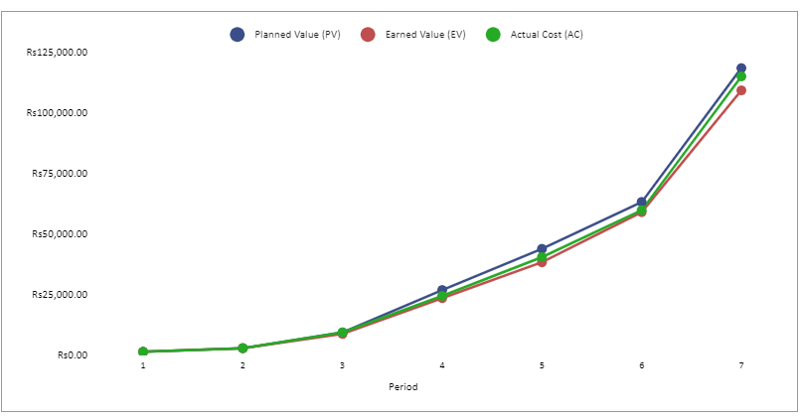

*Figure 10 EV Analysis Graph*

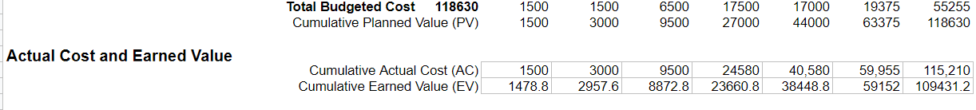

*Figure 11 Summary of EV Analysis*

The earned value analysis is shown in Figure 11. SKANDA's E-Commerce website project spent LKR 115,210.00 of its LKR 121,880.00 budget up to week seven. During this time, the project has earned LKR 109,431.02 in cumulative value.